IntelliJ installation

1.Go to <https://www.jetbrains.com/idea/>

2.Click download



3.Pick community version

4.Perform default installation

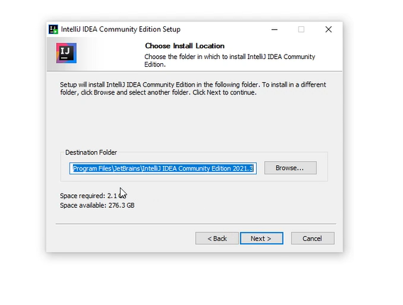

5.Run the app

